- Left Handed Red Mens Colored Leather Golf Gloves
- Material: all weather red soft cabretta leather
- Smooth Palm for Maximum Feel
- One size fits all
- Men left handed golf glove
- Improved Grip & Durability In All Weather Conditions
- Adjustable Closure: Thin, Light & Secure Fit
- Elastic lycra design: Soft Feel & Moisture Absorption
- OEM printing, embroidery, rubber and epoxy logo
- Timely delivery and competitive unit price.
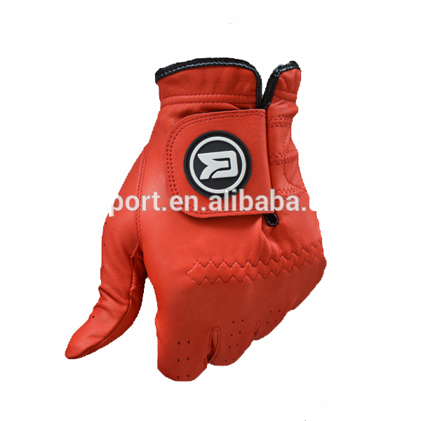
More information please click:www.tt-golf.com

